Ron Singler  
Singler Farms Simmentall  
Witt, IL

Cell : 217-556-4595

Home : 217-594-7191

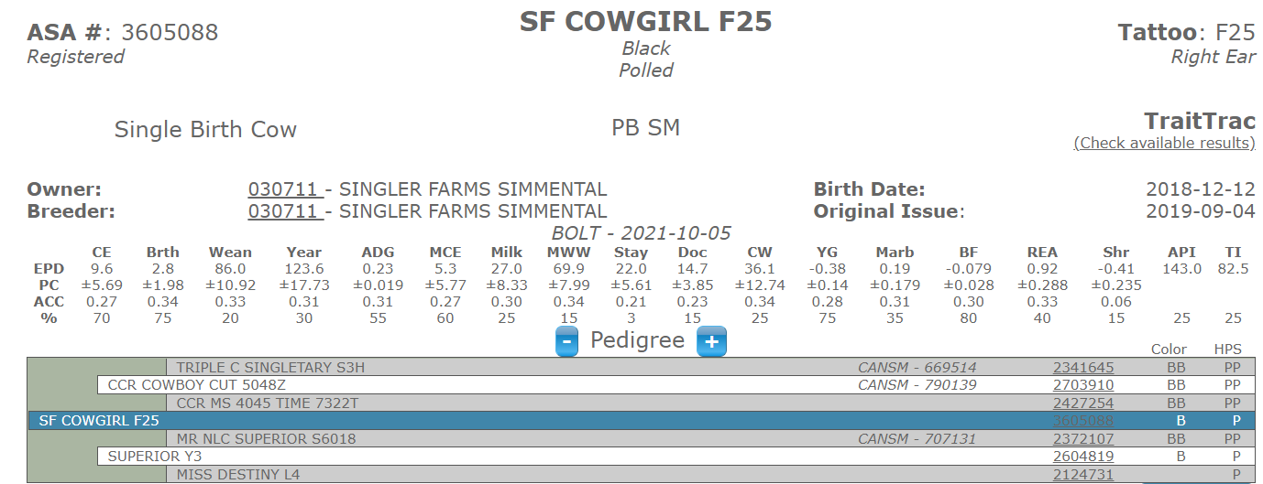PE ½ Simm ½ Angus (3101541) 4-29-21 to 6-16-21 and ¾ Simm ¼ Angus (3760826) 6-20-21 to 10-20-21

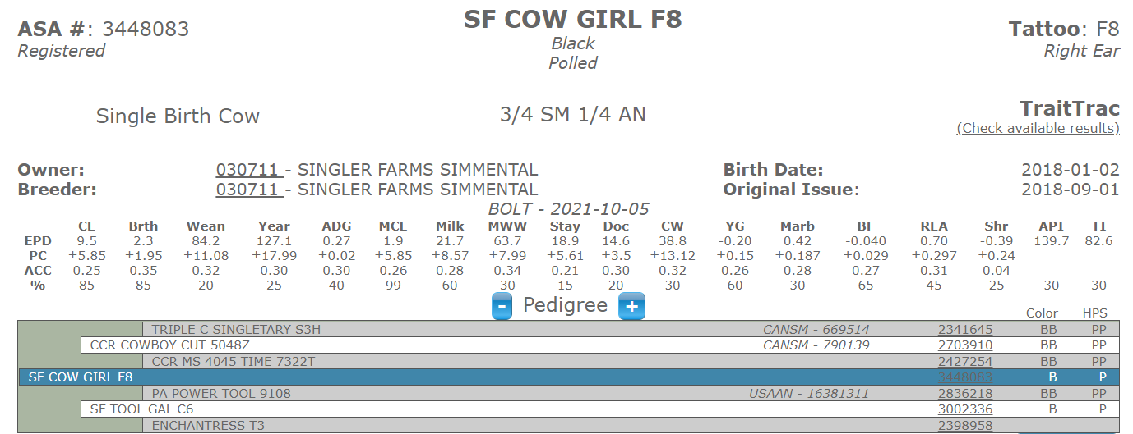PE Pure Bred Simm (3690998) 4-30-21 to 10-20-21

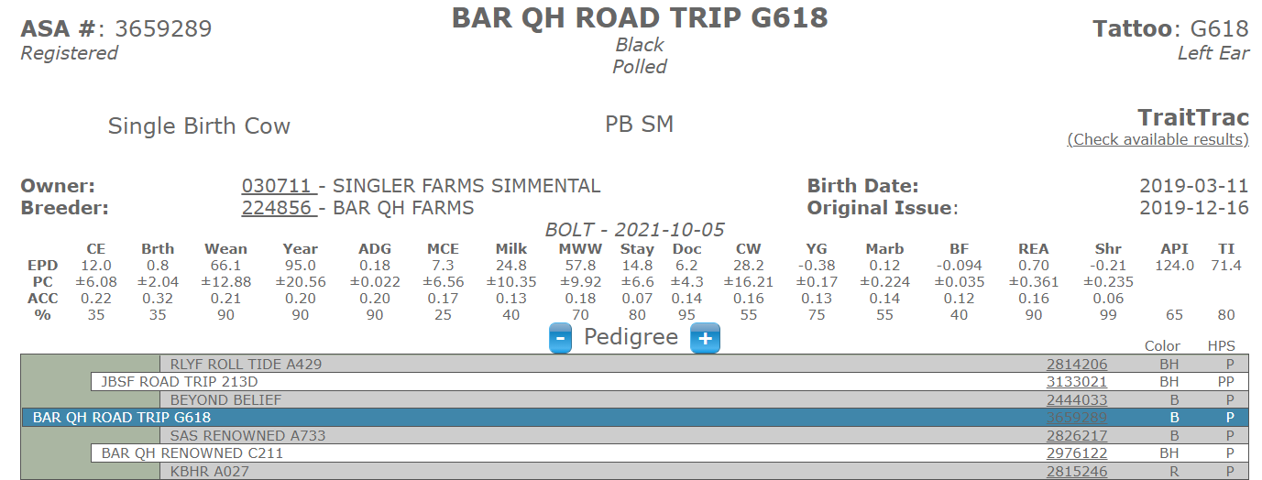PE 3/4 Simm (3760839) 4-30-21 to 5-27-21 and Pure Bred Simm (3690998) 5-28-21 to 10-20-21

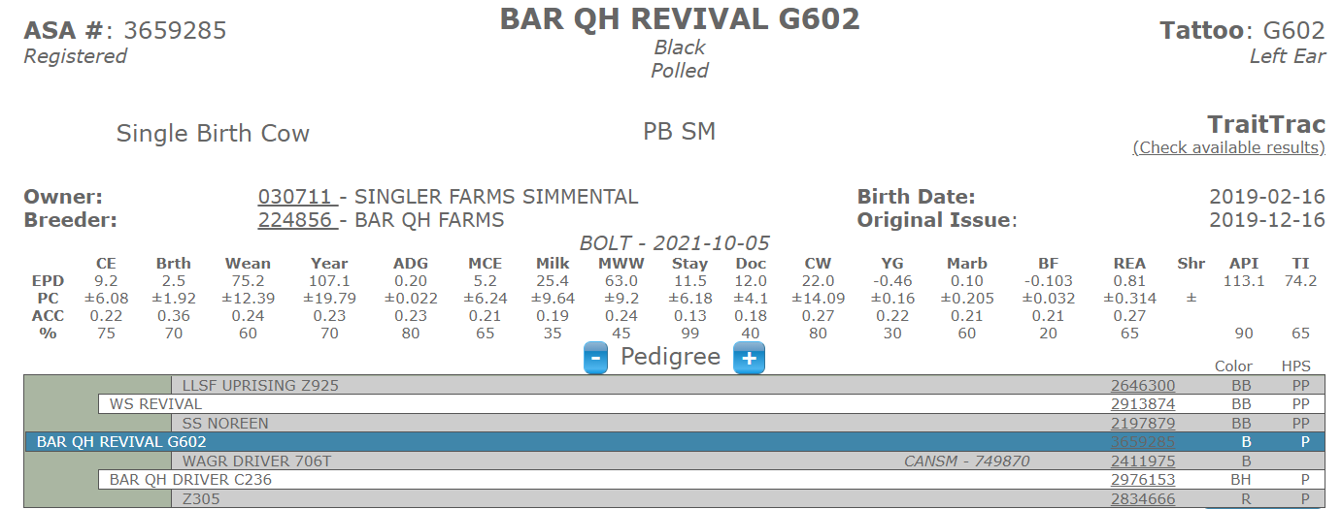PE 3/4 Simm (3760839) 4-30-21 to 5-27-21 and Pure Bred Simm (3690998) 5-28-21 to 10-20-21

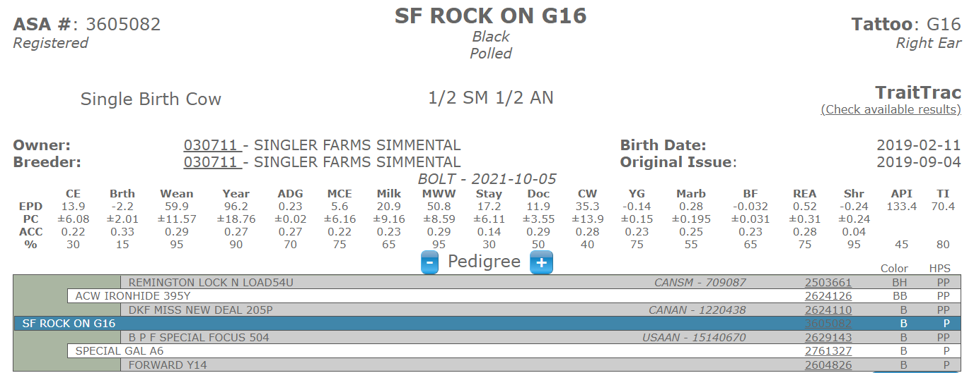AI Optimizer 4-27-21 and Pure Bred Simm (3690998) 5-10-21 to 10-20-21

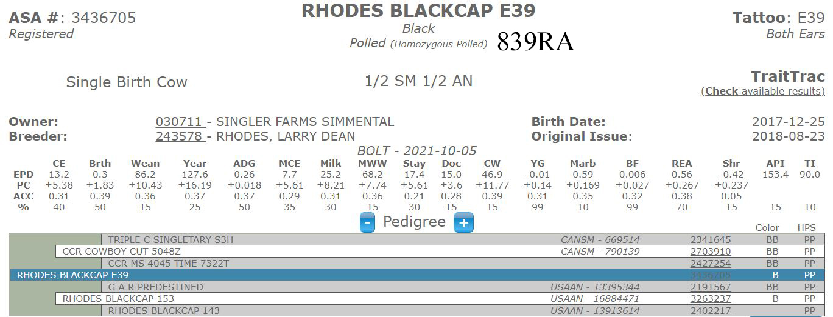AI TJ Frosty 4-21-21, PE ½ Simm ½ Angus (3101541) 4-29-21 to 6-16-21, and ¾ Simm ¼ Angus (3760826) 6-20-21 to 10-20-21

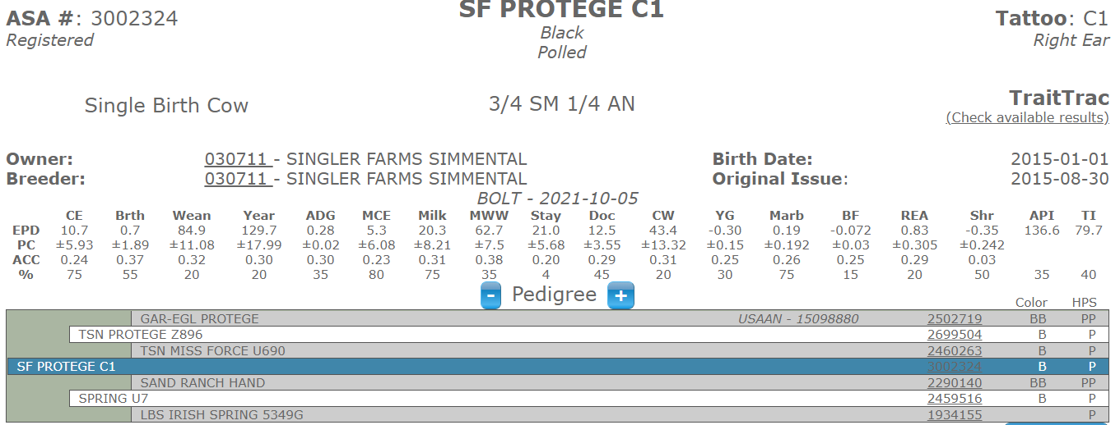AI TJ Frosty 4-3-21, PE ½ Simm ½ Angus (3101541) 4-29-21 to 6-16-21, and ¾ Simm ¼ Angus (3760826) 6-20-21 to 10-20-21

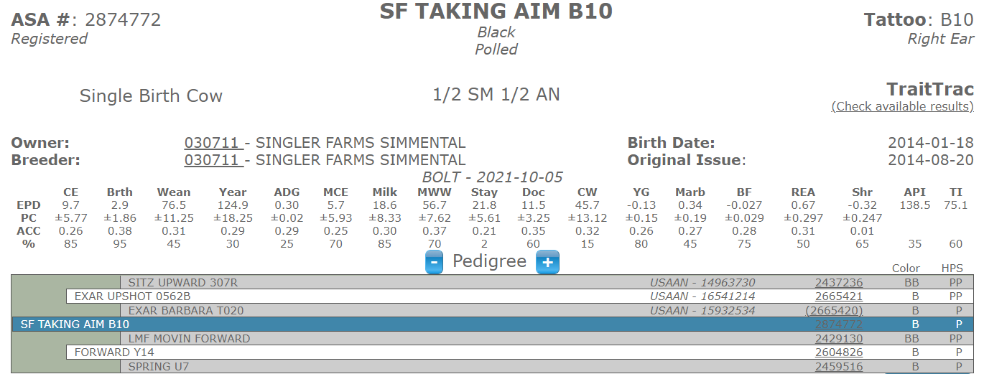AI TJ Frosty 3-22-21, PE ½ Simm ½ Angus (3101541) 4-15-21 to 6-16-21, and ¾ Simm ¼ Angus (3760826) 6-20-21 to 10-20-21