Singler Farms Simmental
Ron Singler
Witt, IL

Contact Information
Phone Number: 217-594-7197
Cell Number: 217-556-4595

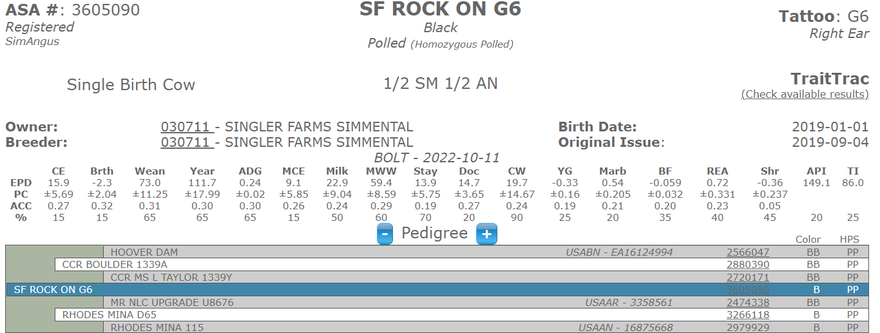
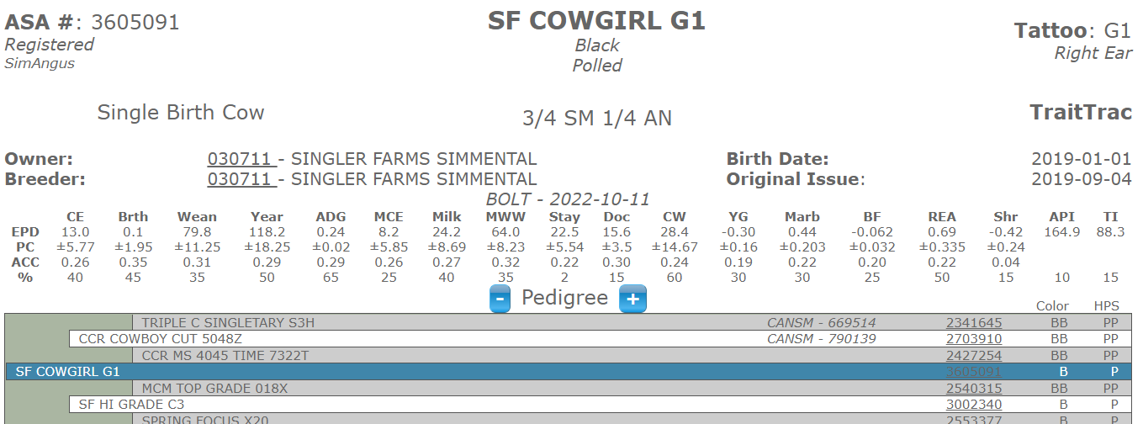
PE to Sim/Angus Bull -#3927174 4-30-22 to 8-20-22
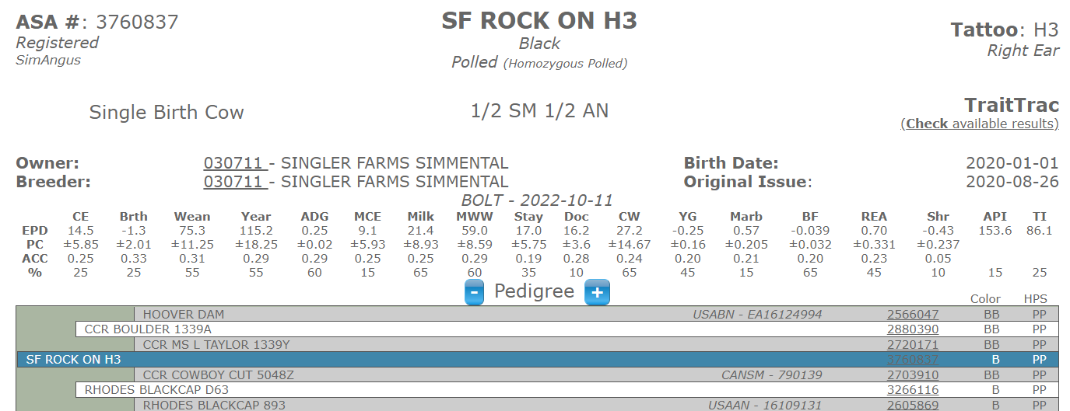
Pure Bred Sim Bull #6990998 from 4-26-22 to 7-3-22
PE to Sim/Angus Bull -#3927174 4-30-22 to 8-20-22

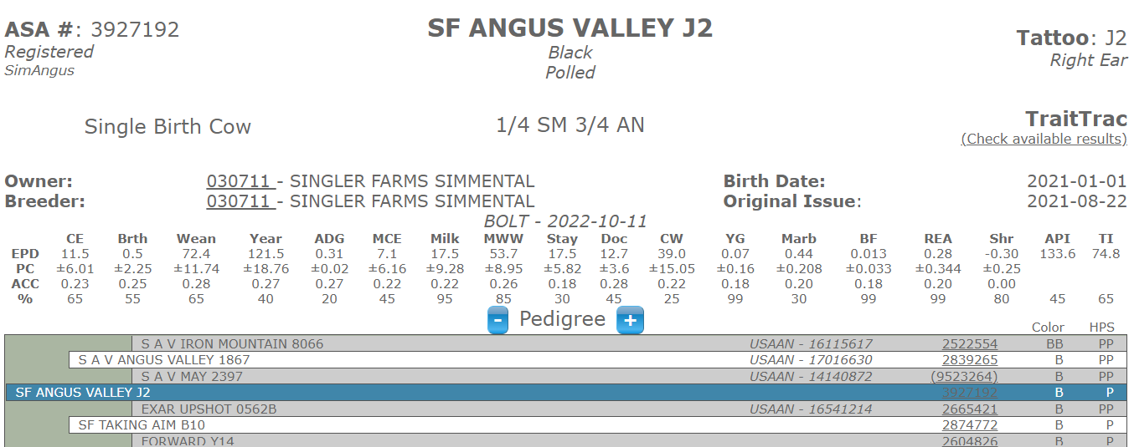
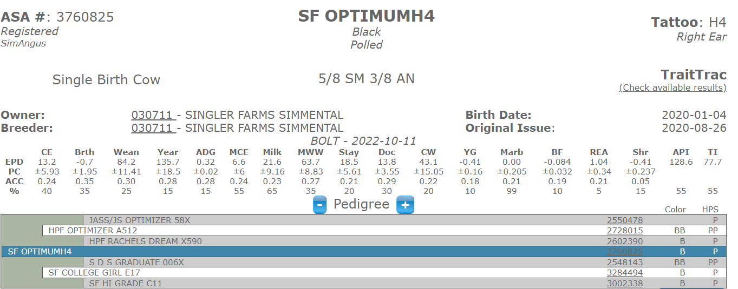
Pure Bred Sim Bull #6990998 from 4-26-22 to 7-3-22
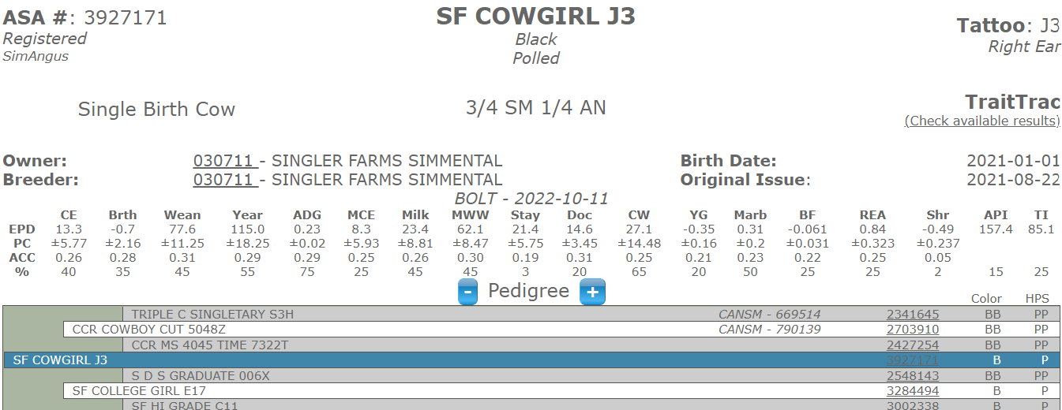
PE Low BW Angus Bull Betzolds Confidence (20155981) PE 4-29-22 to 7-7-22

PE Low BW Angus Bull Betzolds Confidence (20155981) PE 4-29-22 to 7-7-22

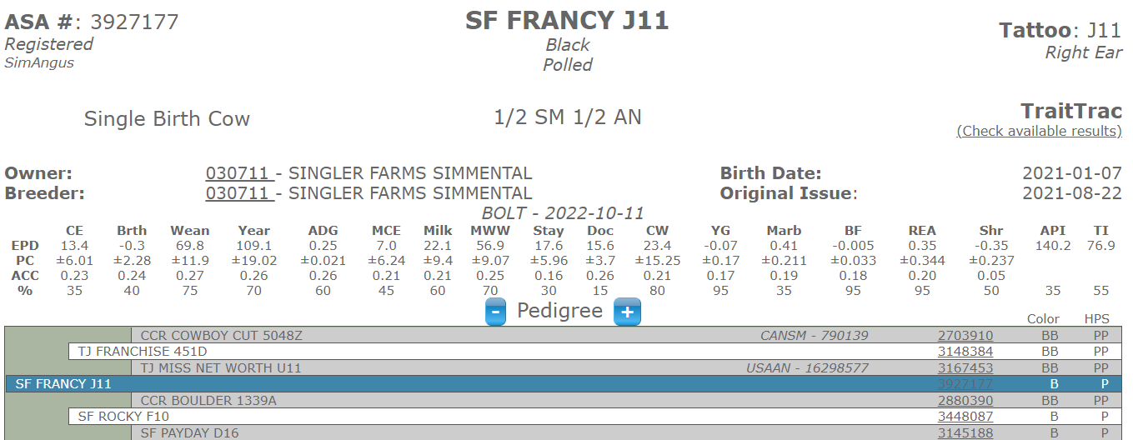
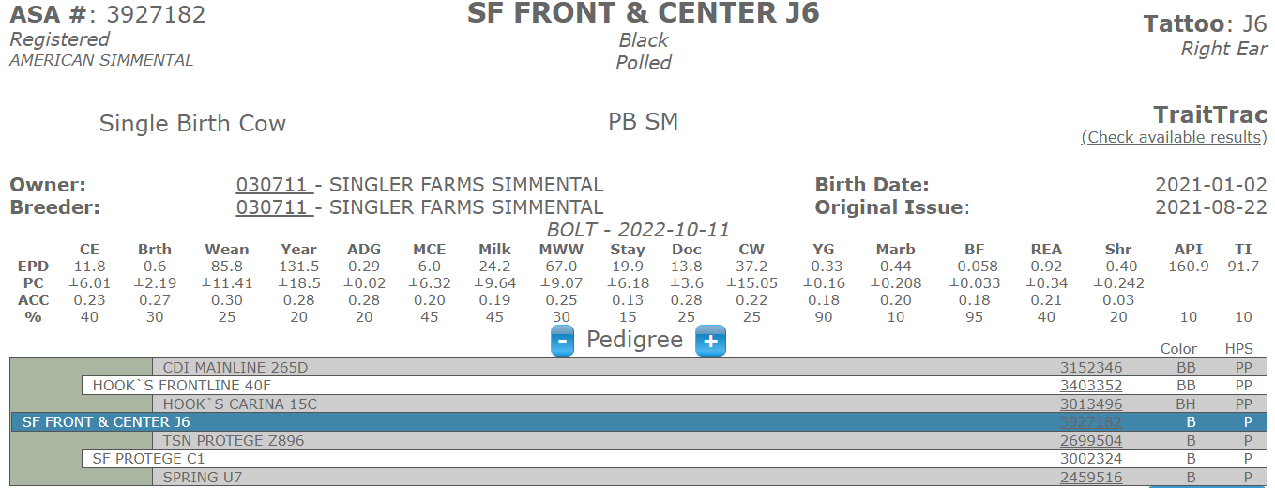
PE Low BW Angus Bull Betzolds Confidence (20155981) PE 4-29-22 to 7-7-22
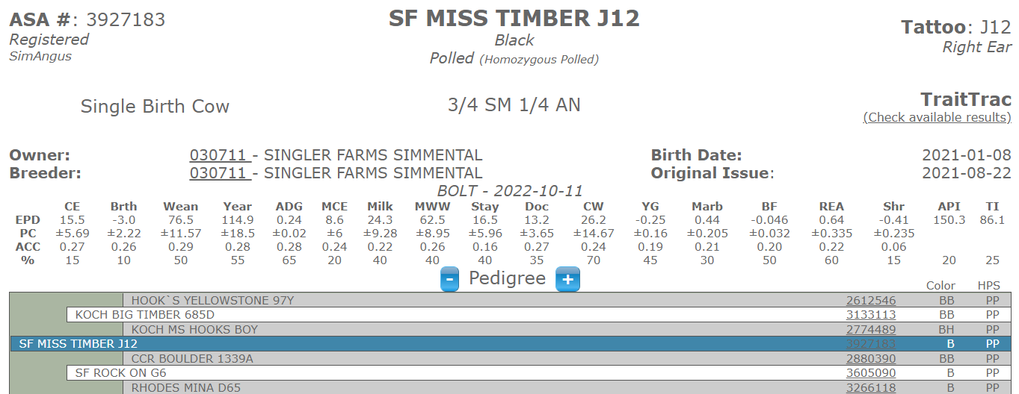
Low BW Angus Bull Betzolds Confidence (20155981) PE 4-29-22 to 7-7-22
Low BW Angus Bull Betzolds Confidence (20155981) PE 4-29-22 to 7-7-22

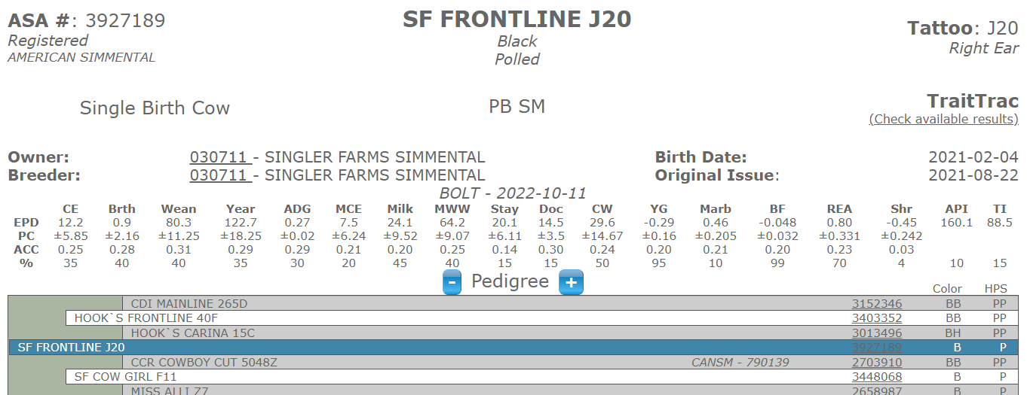
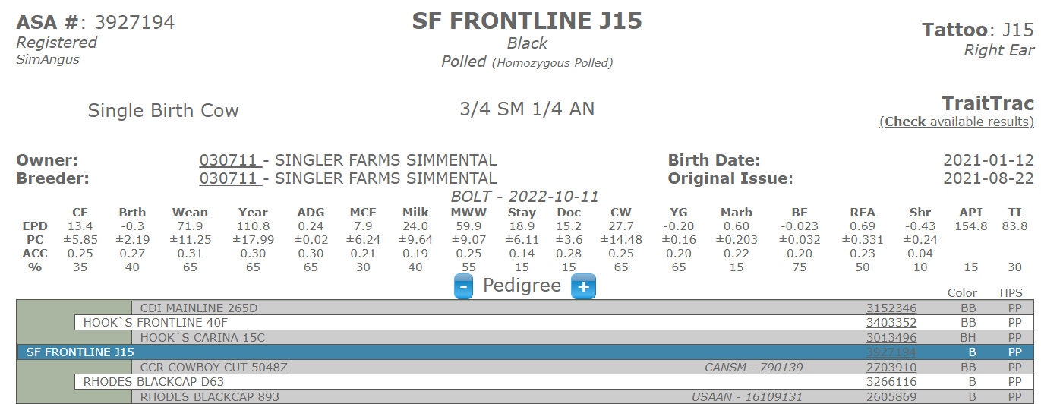
Low BW Angus Bull Betzolds Confidence (20155981) PE 4-29-22 to 7-7-22
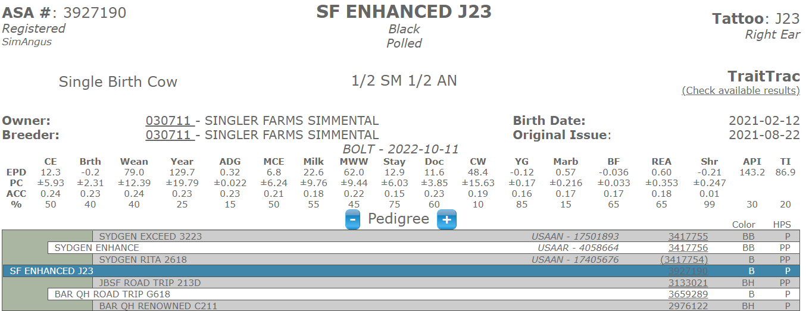
AI CCR Boulder 4-4-22 PE - Low BW Angus Bull Betzolds Confidence (20155981) 4-29-22 to 7-7-22
Low BW Angus Bull Betzolds Confidence (20155981) PE 4-29-22 to 7-7-22

