Singler Farms Simmental  
Ron Singler

Witt, IL

Contact Information

Phone Number: 217-594-7197

Cell Number: 217-556-4595

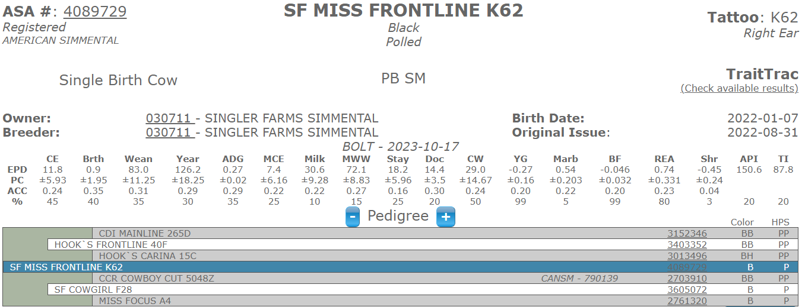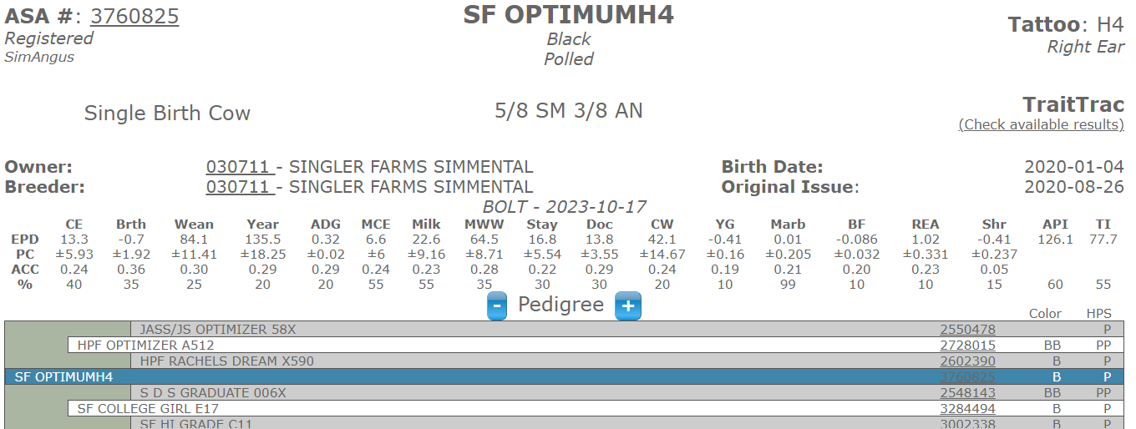Heifer calf by Hooks Front Line – Born 8-28-23 BW 70lbs Pasture exposed to Low BW Sim/Angus 9-25-23 to 11-10-23

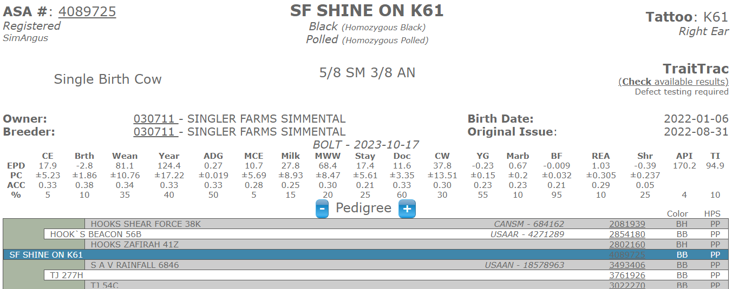AI TJ Arrowhead 4-6-23 Blood Tested To AI Date Pasture exposed to Low BW Sim/Angus 5-5-23 to 10-6-23

AI TJ Arrowhead 4-6-23 Blood Tested To AI Date Pasture exposed to Low BW Sim/Angus 5-5-23 to 10-6-23

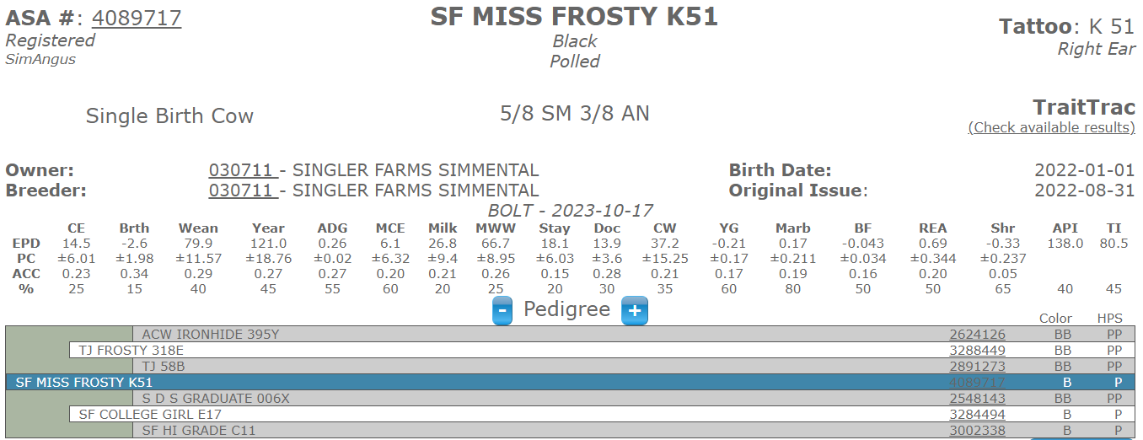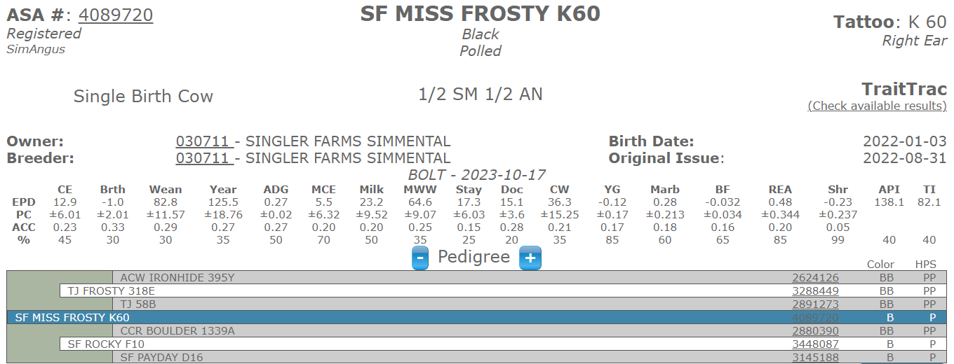AI TJ Frosty 4-5-23 Blood Tested To AI Date Pasture exposed to Low BW Sim/Angus 5-5-23 to 10-6-23

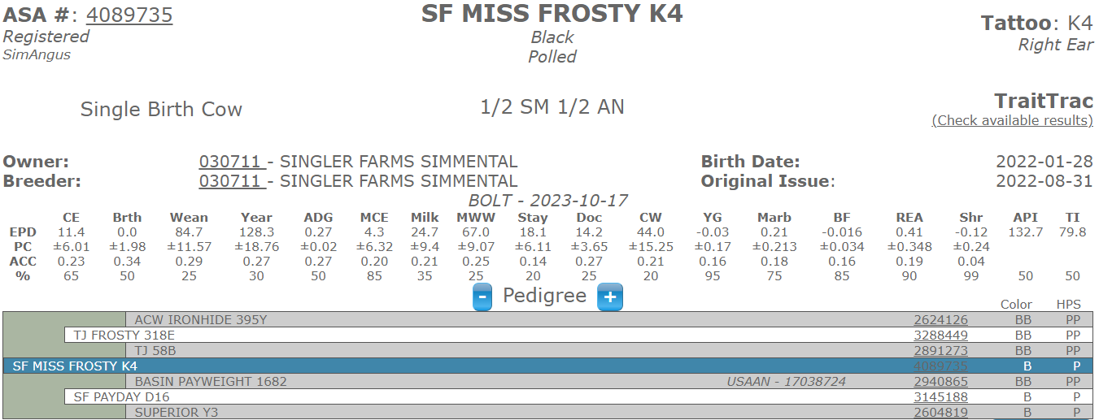Pasture exposed to Low BW Sim/Angus 5-5-23 to 10-6-23

Pasture exposed to Low BW Sim/Angus 5-5-23 to 10-6-23

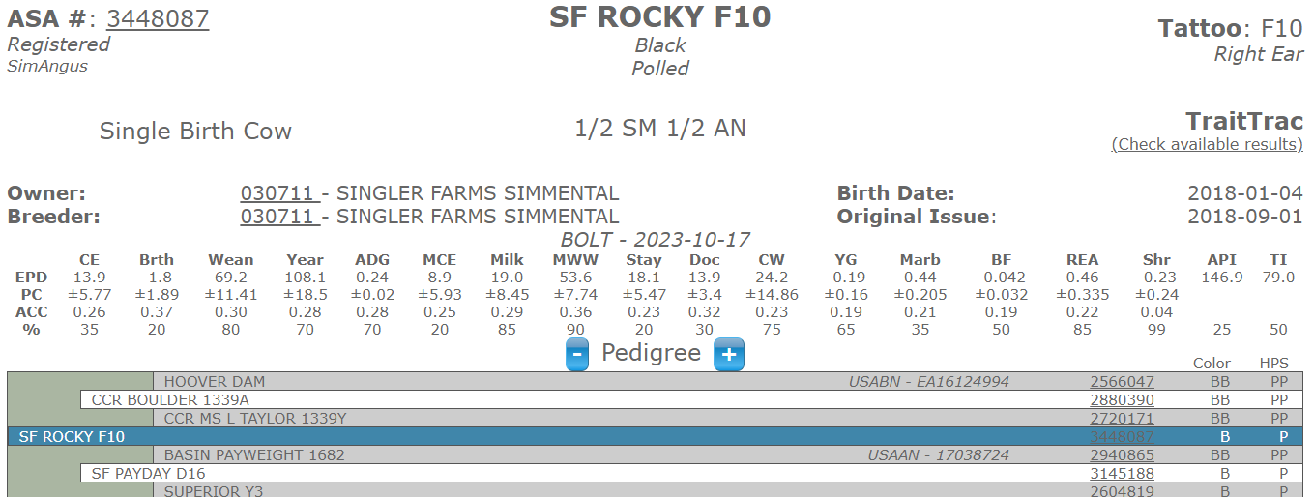

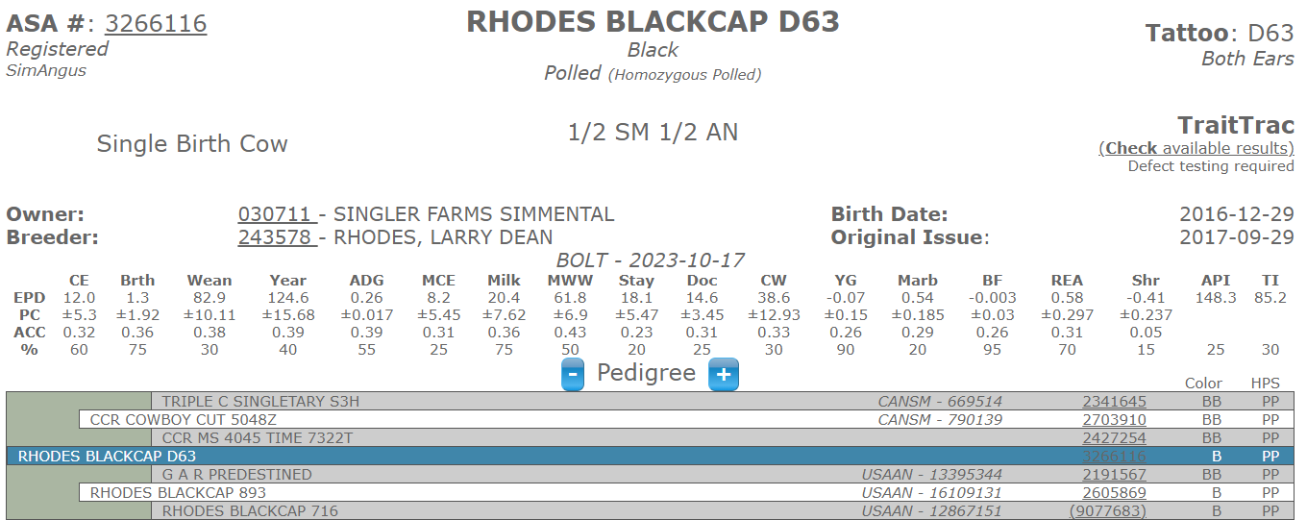­AI TJ Frosty 3-14-23 Pasture exposed to Low BW Sim/Angus 4-19-23 to 9-25 -23

Pasture exposed to Low BW Sim/Angus 4-19-23 to 9-25-23

­­

­

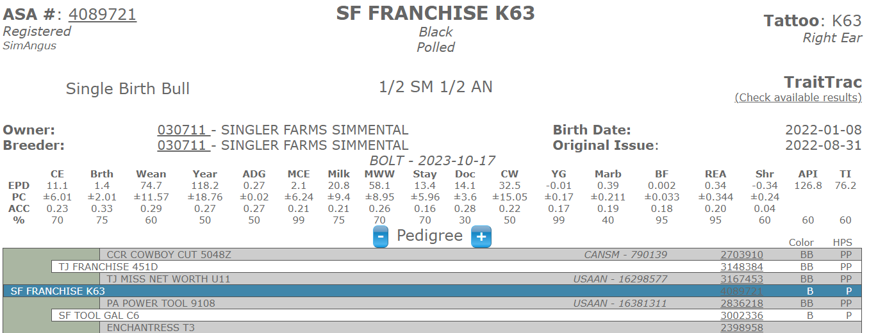

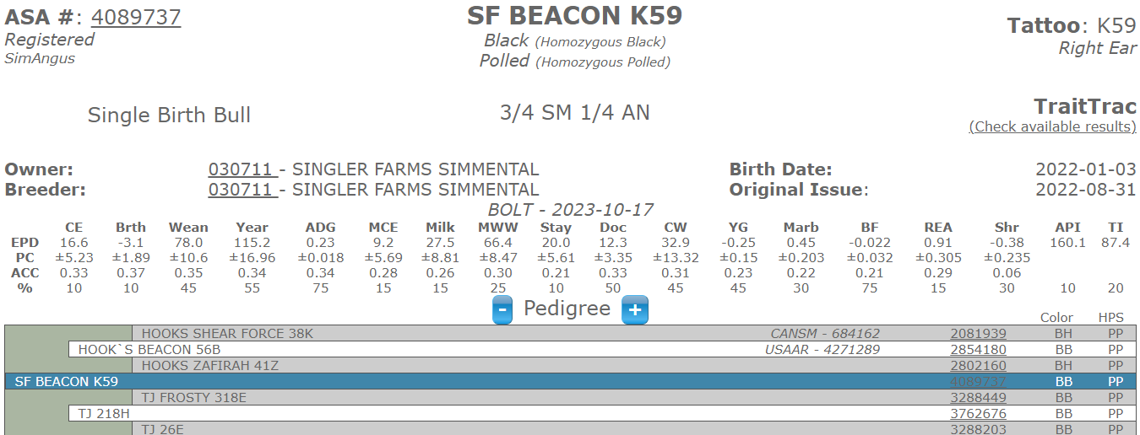Sim/Angus Bull ­Moderate BW 80lbs

Sim/Angus Bull Moderate BW 70lbs Top 10% CE, BW, & API